TOURISM AWARD MARCO POLO
for the creation of a CEE tourist product, service or activity
for Chinese tourists from March 2020 until 15th March 2022

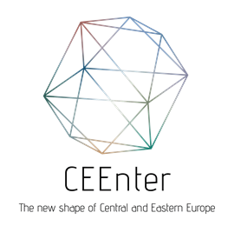

APPLICATION FORM –
National and Regional Tourism Organizations - 2022

Please use this form to apply for the Tourism Award Marco Polo 2022.
Application Deadline: 30thJune 2022
Send to e-mail tcc@mfa.gov.hu

Applicant:
Address:
Website:
Website in Chinese (if applicable):
Contact data
Name:
E-mail:
Phone:
Give your company profile in max. 150 words. (Refer to your results in the Chinese market before the COVID-19 pandemic and how you changed your focus as a consequence of the crisis.)

Underline the area(s) that your new strategy targeting the Chinese market excels in (you can choose multiple)

- Sustainability
- Digital Marketing
- Use of Social Media
- Deeper Chinese Visits (longer stays in one CEE country, at fewer destinations, environmentally friendly travels during the holiday, active holidays, slow tourism and getting to know a place(s) in detail)
- Combination of the local character and the emerging new trends. Addressing the high-end traveler
- Other creative ideas

Please describe in approximately 1200 words your new strategy you prepared for the post COVID era and/or activities you have been doing for the past 2 years. Please focus on the areas that you would like to introduce in more detail.

Please support your application with supplementary documents (marketing materials, media releases, links, photos, videos, customer reviews, etc.):

Any other relevant information (optional):
Date, place, signature of the Applicant:

